1. Before performing following steps Redeem Your Azure Pass
2. Log into [https://dev.azure.com/{your_org_name}](https://dev.azure.com/%7byour_org_name%7d)



1. Click on upper right corner account manager 🡪 **Switch directory**

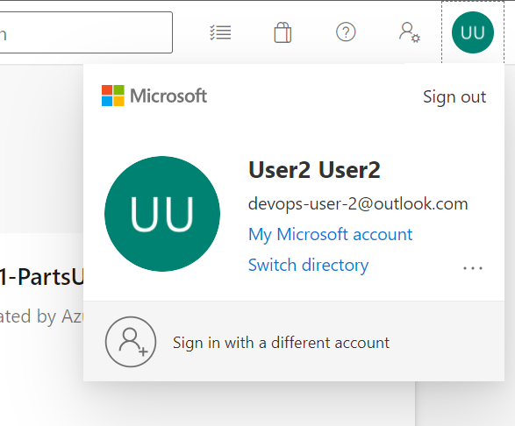

1. Switch to default directory
2. Click on Organization Setting 🡪 General 🡪 Billing

1. In MS Hosted CI/CD text box type 1 instead of 0
2. After this you will be able to use MS Hosted Agent for running your pipeline